***Gergo Nagy - Analysis and Design Unit (SQA PDA: Software Development)***

A.D 1 Use Case Diagram

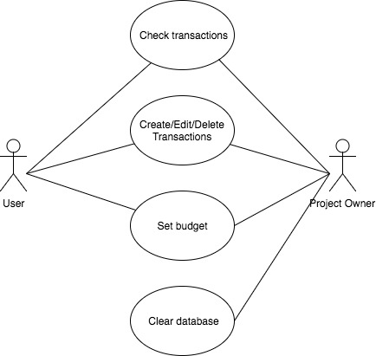

A.D 2 Class Diagram

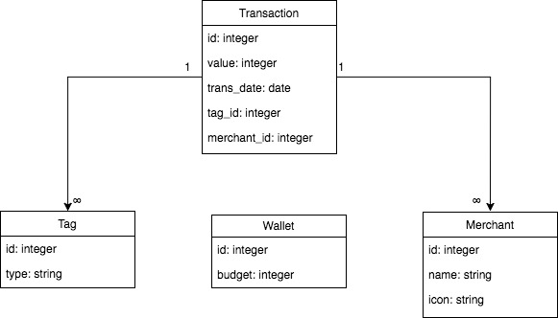

A.D 3 Object Diagram

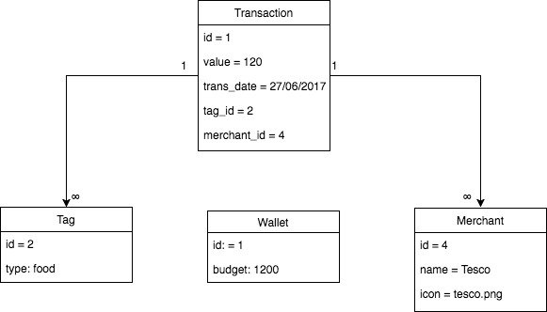

A.D 4 Activity Diagram

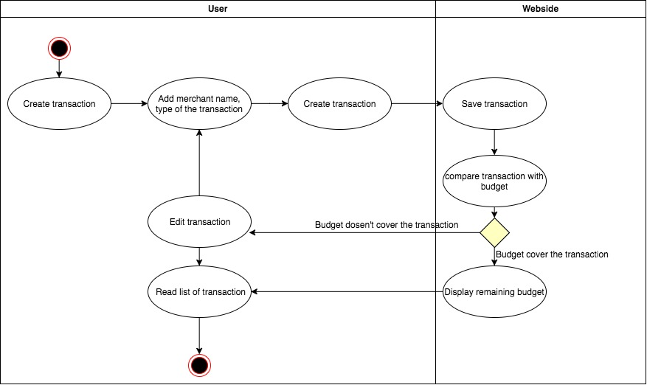

A.D 6 Implementations Constraints Plan

|  |  |  |
| --- | --- | --- |
| Constraints | Possible Effect of Constraints on Product | Solution |
| Hardware and Software platforms | Small screen | Optimize different size of screens |
| Performance requirements | Slow website | Optimize the size of the database |
| Persistent storage and transactions | ? | ? |
| Usability | Complicated usage | Simple navigation |
| Budgat | Running out of budget | Planing |
| Time | Half finished website | Use of MoSCoW |